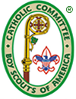
DIOCESAN CATHOLIC COMMITTEE ON SCOUTING (DCCS)
PURPOSE: The purpose of the DCCS is to provide ongoing religious activities for the spiritual development of Scouts and Scouters in the Diocese of Evansville. The DCCS encourages and provides assistance to all Scouts but primarily Catholic Scouts, especially those in units sponsored by Catholic parishes and organizations, to help them live up to the Scout Oath “Duty to God” and the twelfth point of the Scout Law “To be Reverent” by practicing their Catholic faith. The DCCS is the Diocesan branch of National Catholic Committee on Scouting (NCCS). The NCCS is an organization approved by the United States Conference of Catholic Bishops (USCCB), that has a long and storied history of working closely with the BSA in coordinating efforts to develop youth with proper values. The NCCS recognizes the Scouting program in this regard with its emphasis on service, leadership. and appreciation of God’s gift of the Great Outdoors. The DCCS has a website— www.evdccs.com --which provides additional information about contacts, meetings, training, emblems, and activities.
YOUTH MINISTRY: The DCCS is part of Youth Ministry in the diocese which reports to the Bishop of Evansville through the Youth and Young Adult Ministry Department. The Scout Chaplain is Deacon Charles Koressel (ckoressel@evdio.org). To this end, the DCCS encourages Scout Leaders to recognize their role in the church as Youth Ministers. As such they have a responsibility to help young people in their role as disciples of Christ in today’s secular world, to draw them more into the faith community, and to promote the moral and spiritual growth of the individual youth. The DCCS provides training in Youth Ministry (contact joerdickinson@gmail.com ) and provides information on how a unit can foster youth participation in their faith (see the document under Committee/Youth Ministry on the DCCS website).
EVENTS: The DCCS sponsors several events each year which include the following:
SCOUT FAITH DAY – February 19, 2022 – Contact Bill Noll at npbknoll@aol.com.
The Scout Faith Day is a half day activity for Cub Scouts (Cubs), Girl Scouts (Brownies or Daisies) and other units sponsored by Catholic organizations such as American Heritage Girls or Knights of St George in the 7 – 10 age group. The program consists of brief presentations, physical activities and games that illustrate our spiritual message of God and our relationship with others. In 2022 the event will be held at Good Shepherd Parrish. The Faith Day is open to all Scouts not just Catholics.
SCOUT/VENTURING RETREAT – March 4- 6, 2022 – Contact Francis Brickey at brickey5@sbcglobal.net
The annual Scout/Venturing Retreat is a weekend event for Scouts and Venturers with presentations, discussions, singing, prayer, liturgies, and activities (with a spiritual message). In 2022 this event will be held at the Catholic Center in Evansville. Meals are provided, and the Scouts and Leaders sleep in the gym. The Retreat concludes on Sunday with a Mass with the Bishop. The Retreat is open to all Scouts not just Catholics
CATHOLIC LEADERSHIP DEVELOPMENT (SPIRITUAL FORMATION) – March 5, 2022 – Contact is joerdickinson@gmail.com.
This daylong course for adult leaders fosters a look at one’s own Christian leadership, holiness, and commitment, so as to become better examples to the youth. It usually occurs during the Scout/Venturing Retreat. It also encourages activities in the unit to promote a Catholic identity. The course involves discussions by the participants, use of Scripture, singing, and prayer to accomplish this goal.
OTHER ACTIVITIES:
The DCCS holds quarterly meetings, and all interested are invited to attend and participate. Time and place of the next meeting can be found on the DCCS website.
The DCCS promotes and provides counselor training for Religious Emblems for both Cubs and Scouts. The contact for more information about youth emblems and adult recognition is jackmartin2502@gmail.com.
The DCCS encourages the study of vocations in youth through a local religious recognition —the Order of St. Dominic Savio--which emphasizes service to the church. Contact is matthewjkremer@gmail.com.
The DCCS promotes the formation and support of units sponsored by Catholic Parishes. Contact for this Membership Committee is Jim Voelker at javcoent@aol.com.
The DCCS helps to maintain the chapel at Old Ben Scout Reservation. For more information contact Tom Elsner at tome@tristate-bearing.com.
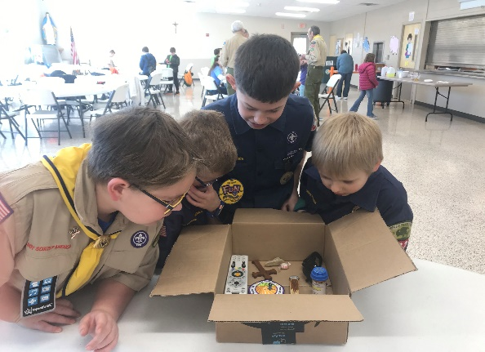
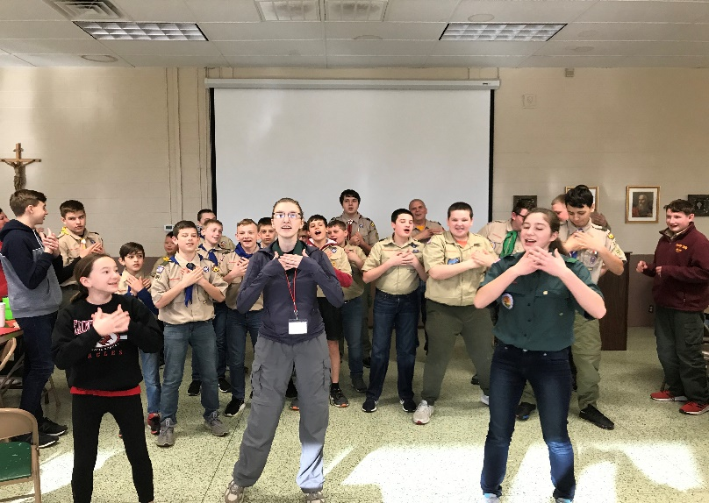
Religious Kim’s Game Singing at the Scout/Venturing Retreat 2020
Scout Faith Day 2020

